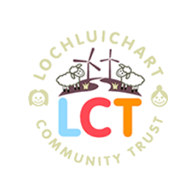
Minutes of the Extraordinary General Meeting of the Lochluichart Community Trust
19 January 2022 via Zoom

Present:
LCT Directors/Company Secretary:
Uisdean Menzies (Chair) Karen Grant (Treasurer) Margaret Ross
Carol Smith (Company Secretary)

Members:
Sue Tarr Jean Bailey Pam Morrison Bob Moir John Fenwick
Sadie Harris Jeanette Fenwick Simon Friend Mark Dale Mike Franklin
Sharon Wright

Proxy received:
22 proxies

Non members: Alpin Stewart (Munro & Noble) Tina Hartley (TGDDC)
Kenny Maclean (GDCC)

Apologies: None

- Welcome
UM opened the meeting and welcomed the members and guests and explained that the meeting would be held via Zoom

- Ordinary Resolution to elect a director
Following a count of the online and proxy votes Pamela Morrison was elected as director with 895 of the votes of members present or by proxy. Jean Bailey was not elected as a director as she did not receive the 50% of member votes required to be elected.

Following the vote there was disappointment voiced that Jean had not been elected as an LCT Director. There was general agreement that work needed to be done to get more people within the community as members of LCT. Jean Bailey thanked the members for their votes and the comments and support of those on the call.

It was also suggested that a welcome pack could be created for newcomers to the area which would provide details of all of the community organisations.

